**Decision Tree:-**

A **Decision Tree** is a supervised machine learning algorithm used for classification and regression tasks .It splits data into branches based on feature values, forming a tree-like structure where each node represents a decision, and leaf nodes represent the final outcome.**Key Components of a Decision Tree**

1. **Root Node**: The topmost node representing the entire dataset.
2. **Decision Nodes**: Nodes where the dataset is split based on a feature.
3. **Leaf Nodes**: Nodes representing the final output (class label or value).
4. 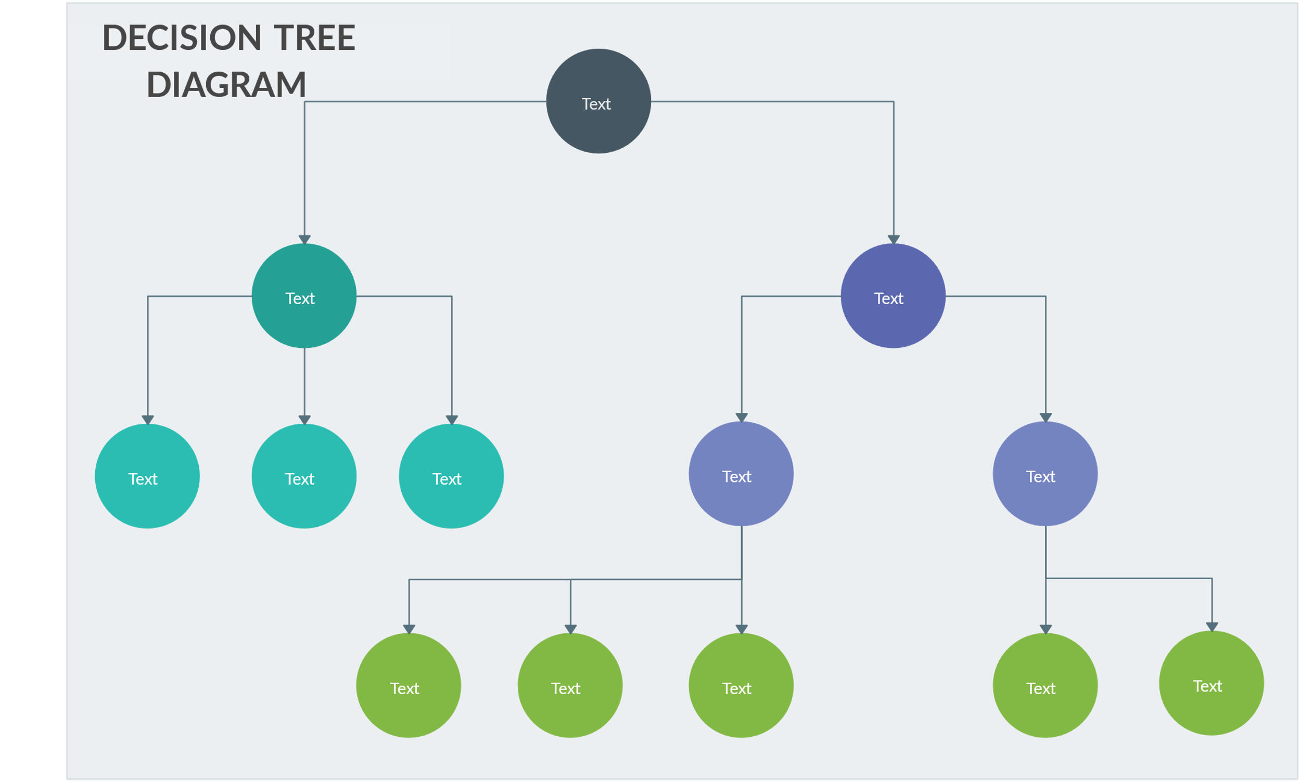**Branches**: The connections between nodes showing decision paths.

**How It Works**

1. **Select a feature** (using criteria like Gini Impurity, Entropy, or Variance).
2. **Split the dataset** based on that feature.
3. **Repeat recursively** until a stopping condition is met (e.g., max depth, minimum samples per leaf).
4. **Assign a class label or value** at the leaf nodes.

**Advantages of Decision Trees**

1. Easy to interpret and visualize.  
 2. Works with both numerical and categorical data.  
 3. Requires minimal data preprocessing (no need for feature scaling).

**Disadvantages**

1. Prone to overfitting (mitigated using pruning techniques).  
 2. Can be biased if dataset is imbalanced.  
 3. Splitting can be computationally expensive for large datasets.

**Applications of Decision Trees**

* **Customer segmentation** (e.g., marketing campaigns).
* **Fraud detection** (e.g., financial transactions).
* **Medical diagnosis** (e.g., classifying diseases).
* **Predictive maintenance** (e.g., failure prediction in machinery).